Technical Report

Introduction
This project prepares historical stock-market data for predictive modeling. Daily price and trading-volume observations are enriched with company-level metadata, cleaned, transformed, and divided into chronological training, validation, and test sets. The modeling target is the standardized closing price (`close`).

Data Overview
Two source files are used: `historical_stock_prices.csv`, containing daily observations, and `historical_stocks.csv`, containing company metadata. The price data includes `ticker`, `date`, `open`, `high`, `low`, `close`, `adj_close`, and `volume`; the metadata contributes `exchange`, `name`, `sector`, and `industry`. A derived `decade` field records the decade of each observation. After the initial ticker-based left join, the notebook reports 20,973,889 rows and 13 columns. After feature engineering and removal of rows with missing rolling-feature values, 20,696,008 rows remain.

Methodologies
--- Missing Values
The notebook reports missing-value counts after joining the files. It converts `sector` and `industry` to numeric values and fills their missing entries with forward-fill followed by backward-fill. Rolling calculations later produce missing values at the beginning of ticker histories; rows containing missing values are dropped after feature engineering. The approach does not document a separate imputation policy for any other columns.
--- Outlier Detection and Resolution
The interquartile range (IQR) rule is applied independently to `open`, `close`, `adj_close`, `low`, `high`, and `volume`. For each column, values below $Q1 - 1.5 \times IQR$ or above $Q3 + 1.5 \times IQR$ are identified and clipped to those bounds. The executed output reports about 1.69 million flagged records for each unadjusted price column, 1.78 million for `adj_close`, and 2.91 million for `volume`. These are column-wise counts and may include the same rows across columns. The accompanying six-panel histograms show the distributions after capping, using a 100,000-row sample when the dataset exceeds one million rows.
--- Error Identification and Correction
The notebook checks for non-positive values in the five price columns and in `volume`. Its recorded run reports no such values. These checks are diagnostic: the code prints findings but does not repair or remove any records if invalid values are present. The source metadata row whose ticker is the erroneous header-like value `Symbol` is removed before joining.

--- Feature Engineering
Rows are sorted by `ticker` and `date` before computing per-ticker features. `daily_return` is the percentage change in `close`; `SMA_10` and `SMA_50` are 10- and 50-observation rolling means; and `volatility_10` is the rolling 10-observation standard deviation of daily returns. Rows with missing engineered values are removed. Rolling windows are observation-based, not explicitly calendar-day windows.
--- Data Normalization and Standardization
`StandardScaler` is applied to `open`, `close`, `adj_close`, `low`, `high`, `volume`, `daily_return`, `SMA_10`, `SMA_50`, and `volatility_10`, transforming the selected columns to standardized values. In the current notebook order, the scaler is fitted on the full dataset before the chronological split. For an unbiased validation/test evaluation, fit the scaler on training data only and apply that fitted scaler to validation and test data.
--- Categorical Variable Encoding
`sector` and `industry` are converted to integer codes with `pandas.factorize`; missing values are then filled and the columns are treated as numeric. This is integer/ordinal coding, not one-hot encoding, and can imply an ordering that categories do not inherently have. `ticker`, `name`, and `date` are excluded from the model feature matrix; `exchange` remains as a string-valued feature in the current split, so it will need encoding before use with estimators that require numeric inputs.

Data Integration
The two files are joined with a left merge on `ticker`, keeping price observations and attaching matching company metadata. The price `date` column is converted to datetime, and `decade` is derived from its year. The join assumes the metadata has an appropriate ticker-level record; the notebook does not report a duplicate-key validation or unmatched-ticker audit.

Data Splitting
The processed dataset is sorted by `date` and split by row position into 70% training, 15% validation, and 15% test sets. The recorded sizes are 14,487,205 training rows, 3,104,401 validation rows, and 3,104,402 test rows. The target is `close`; `date`, `ticker`, `name`, and `close` are excluded from `X`, while all other columns are included. This preserves global date order, although rows from different tickers on the same date may fall on opposite sides of a boundary if that date is not handled as a group.

Decision Rationale
Capping retains observations while reducing the influence of extreme values, which is preferable to deleting a large number of potentially informative market records. Chronological splitting is used to approximate forecasting on future observations and reduce the temporal leakage associated with random shuffling. Rolling features are grouped by ticker so that one company's price history does not enter another company's calculations. Integer factorization is compact and simple, but categorical encodings without meaningful numeric order should be reconsidered for the chosen model. Finally, train-only fitting of preprocessing steps is essential to keep validation and test results representative of unseen data.

Visualizations
The existing EDA visualization contains post-capping histograms for `open`, `close`, `adj_close`, `low`, `high`, and `volume`. It illustrates the right-skewed distributions and the concentration of observations at the clipping limits. The current notebook does not provide matching before-capping plots or visual comparisons before and after standardization; adding those comparisons would make the effect of each transformation easier to assess.
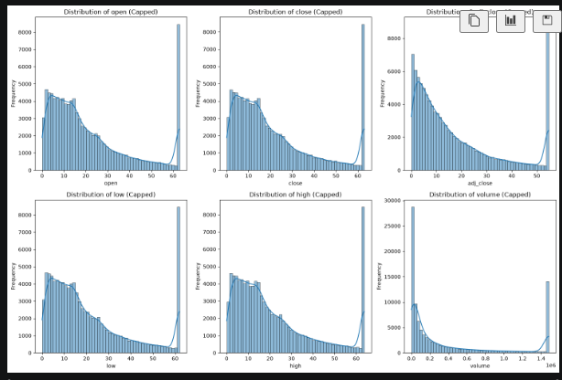

Summary of Transformations
The final processed table has 20,696,008 rows and includes the original market and company fields plus `decade`, `daily_return`, `SMA_10`, `SMA_50`, and `volatility_10`. Selected continuous features are standardized, and the data is divided into chronological feature/target sets. The table is saved as `cleaned_merged_stocks_data.csv`, with separate `X_train`, `y_train`, `X_val`, `y_val`, `X_test`, and `y_test` CSV files. Before modeling, address the preprocessing leakage by fitting the scaler only on training data, encode `exchange` as needed, and confirm that date-boundary grouping and ticker/metadata join assumptions match the intended evaluation.

Conclusion
The preparation workflow integrates daily prices with company metadata, caps IQR-defined extremes, checks basic value constraints, creates ticker-level return and trend features, standardizes continuous variables, and creates time-ordered train/validation/test sets. It produces a large modeling dataset and preserves temporal order. Recommended next steps are to prevent scaler leakage, encode remaining categorical features according to the selected model, validate the join and split boundaries, and evaluate forecasting models against appropriate time-series baselines.

